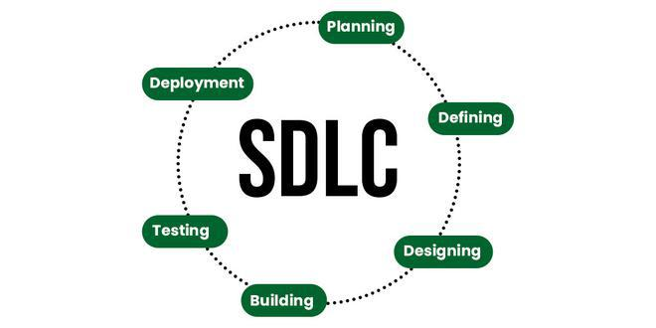
Assignment-1

Assignment 1: SDLC Overview - Create a one-page infographic that outlines the SDLC phases (Requirements, Design, Implementation, Testing, Deployment), highlighting the importance of each phase and how they interconnect.

SDLC Life Cycle:

Requirements

Deployment _{Design}

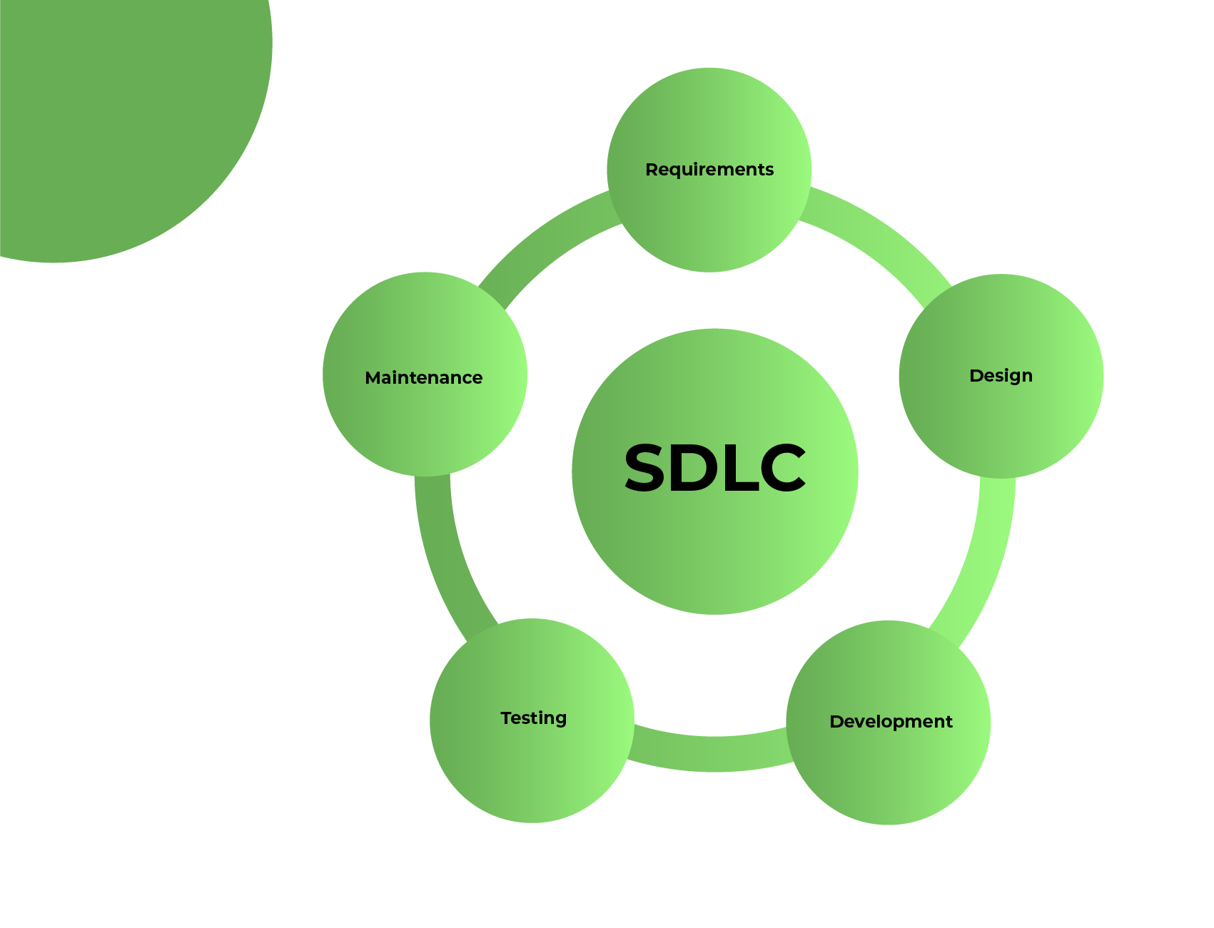

Testing

Implement-

ation

1.Requirements Gathering:

- This phase focuses on understanding the project's goals, what the end-user needs,

and documenting them.

- Key Points:

  - Stakeholder discussions to gather inputs.

  - Identify functional (features) and non-functional (performance, security) requirements.

  - Output: A comprehensive Requirements Specification Document ensures clarity for all stakeholders.

- Prevents misunderstandings, reduces rework, and sets a clear scope for the project.

2.Design

- This phase involves planning the structure and flow of the software. o Key Points:

  - Creation of wireframes (visual layouts) and mockups (detailed design previews).

  - Define how different components will interact (system architecture).

  - Choose the technology stack (e.g., programming languages, frameworks, tools).

  - Provides a blueprint for developers, ensuring the system is efficient, scalable, and aligns with requirements.

- Implementation

- Actual development and coding of the software based on the design.

- Key Points:

- Divide work into manageable modules or tasks.

    - Use version control systems (e.g., Git) to track changes.

    - Follow coding standards to ensure consistency.

  - Translates design into a functional product. Proper implementation minimizes bugs and development time.

- Testing

  - Validate that the software works as expected and meets user needs.

  - Key Points:

    - Unit Testing: Test individual components.

- Integration Testing: Verify that different modules work together.

    - System Testing: Ensure the software works in its intended environment.

    - User Acceptance Testing (UAT): Verify that the software meets business needs.

  - Ensures quality and reliability, identifies issues early, and builds user trust.

- Deployment

  - Release the software to users and make it operational.

  - Key Points:

    - Deploy in production environments.

- Provide user training and support documentation.

  - Perform post-deployment monitoring to address any issues.

- Delivers the product to users, ensuring a smooth launch and adoption.

21958-Lokesh

